workshop

Horse riding activities

Arena

Car Park



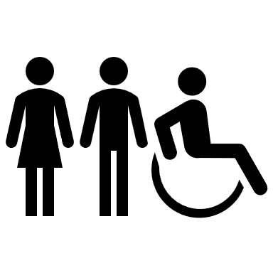

Hay Barn

Stable

Management



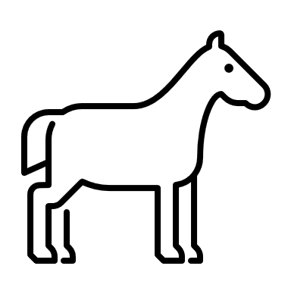





Workshop

Pigs

Stables

Equine Therapy Area

Bug Hotel

Play Tunnel

Beehives

Potting Barn

Summer House

Hand wash

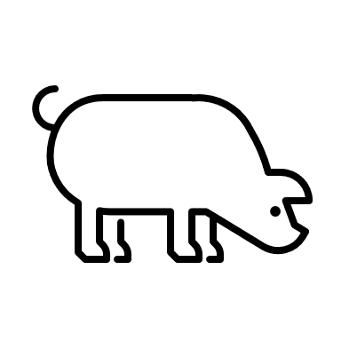

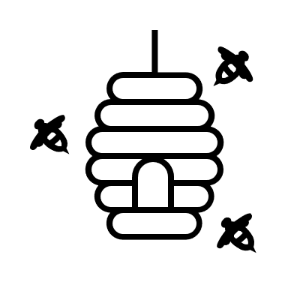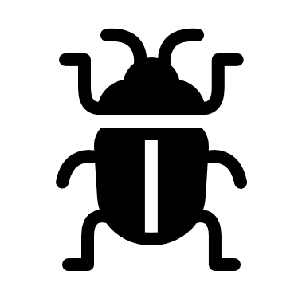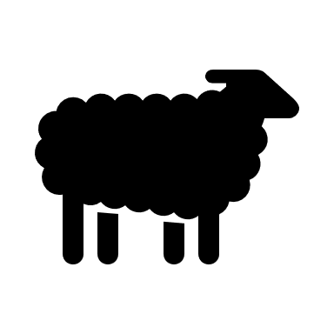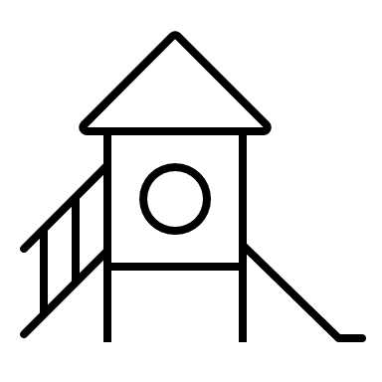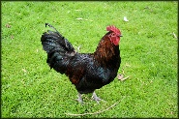

Demo Zone

Meet our animals

Meet our rare breed

Chickens & Ducks

Bug Hotel

Tea with

a Pony

First

Aid

Compost

Area

Woodland Walk

Sheep Barn

Sensory

Garden

Private

Alpacas

Orchard &

Veg plot