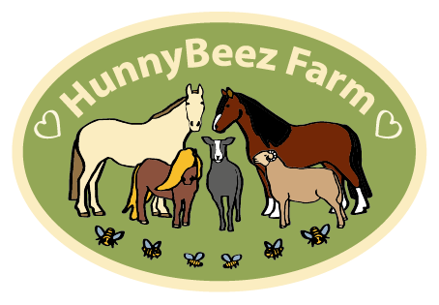

Anti-bullying Policy statement
HunnyBeez Farm Ltd works with children, families and vulnerable adults as part of its activities. The purpose of this policy statement is:
• to prevent bullying from happening between children and young people who are a part of our organisation or take part in our activities
• to make sure bullying is stopped as soon as possible if it does happen and that those involved receive the support they need
• to provide information to all staff, volunteers, children and their families about what we should all do to prevent and deal with bullying.

This policy statement applies to anyone working on behalf of HunnyBeez, including senior managers and the board of trustees, paid staff and volunteers

What is bullying?
Bullying includes a range of abusive behaviour that is
• repeated
• intended to hurt someone either physically or emotionally.

We believe that:
• children, young people and vulnerable adults should never experience abuse of any kind
• we have a responsibility to promote the welfare of all children, young people & vulnerable adults to keep them safe and operate in a way that protects them.

We recognise that:
• bullying causes real distress and affects a person’s health and development
• in some instances, bullying can cause significant harm
• all children, regardless of age, disability, gender reassignment, race, religion or belief, sex or sexual orientation, have the right to equal protection from all types of harm or abuse
• everyone has a role to play in preventing all forms of bullying (including online) and putting a stop to bullying.

We will seek to prevent bullying by:
• developing a code of behaviour that sets out how everyone involved in our organisation is expected to behave, in face-to-face contact and online, and within and outside of our activities
• holding regular discussions with staff, volunteers, children, young people and families, vulnerable adults/carers who use our organisation about bullying and how to prevent it
• providing support and training for all staff and volunteers on dealing with all forms of bullying, including racist, sexist, homophobic, transphobic and sexual bullying
• putting clear and robust anti-bullying procedures in place.

Our regular discussions with staff, volunteers, children, young people and families, vulnerable adults/carers will focus on:
• group members’ responsibilities to look after one another and uphold the behaviour code
• practising skills such as listening to each other
• respecting the fact that we are all different
• making sure that no one is without friends
• dealing with problems in a positive way
• checking that our anti-bullying measures are working well.

Responding to bullying
We will make sure our response to incidents of bullying takes into account:
• the needs of the person being bullied
• the needs of the person displaying bullying behaviour
• needs of any bystanders
• our organisation as a whole.

We will review the plan we have developed to address any incidents of bullying at regular intervals, in order to ensure that the problem has been resolved in the long term.

Diversity and inclusion

We recognise that bullying is closely related to how we respect and recognise the value of diversity. We will be proactive about:
• seeking opportunities to learn about and celebrate difference
• increasing diversity within our staff, volunteers, children, young people, adults/carers
• welcoming new members to our organisation.

Our website provides details of staff members and the position they hold, this includes our Safeguarding Officer and other roles.

