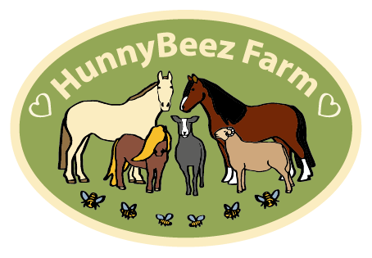

Safeguarding Policy Statement

The purpose of this policy statement is:
• to protect children and young people who attend services within HunnyBeez Farm from harm. This includes the children of adults who use our services
• to provide staff and volunteers, as well as children and young people and their families, with the overarching principles that guide our approach to child protection. This policy applies to anyone working on behalf of HunnyBeez, including senior managers and the board of trustees, paid staff and volunteers.

We believe that:
• children and young people should never experience abuse of any kind
• we have a responsibility to promote the welfare of all children and young people, to keep them safe and to practise in a way that protects them.

We recognise that:
• the welfare of children is paramount in all the work we do and in all the
• decisions we take
• working in partnership with children, young people, their parents, carers and
• other agencies is essential in promoting young people’s welfare
• all children, regardless of age, disability, gender reassignment, race, religion or belief, sex, or sexual orientation have an equal right to protection from all types of harm or abuse
• some children are additionally vulnerable because of the impact of previous
• experiences, their level of dependency, communication needs or other issues
• extra safeguards may be needed to keep children who are additionally vulnerable safe from abuse

We will seek to keep children and young people safe by:
• valuing, listening to and respecting them
• appointing a nominated child protection lead for children and young people, a deputy and a lead trustee/board member for safeguarding
• adopting child protection and safeguarding best practice through our policies, procedures and code of conduct for staff and volunteers
• developing and implementing an effective online safety policy and related procedures
• providing effective management for staff and volunteers through supervision, support, training and quality assurance measures so that all staff and volunteers know about and follow our policies, procedures and behaviour codes confidently and competently
• recruiting and selecting staff and volunteers safely, ensuring all necessary checks are made
• recording and storing and using information professionally and securely, in line with data protection legislation and guidance [more information about this is available from the Information Commissioner’s Office: ico.org.uk/for organisations]
• sharing information about safeguarding and good practice with children and their families via leaflets, posters, group work and one-to-one discussions
• making sure that children, young people and their families know where to go for help if they have a concern
• using our safeguarding and child protection procedures to share concerns and relevant information with agencies who need to know, and involving children, young people, parents, families and carers appropriately
• using our procedures to manage any allegations against staff and volunteers appropriately
• creating and maintaining an anti-bullying environment and ensuring that we have a policy and procedure to help us deal effectively with any bullying that does arise
• ensuring that we have effective complaints and whistleblowing measures in place
• ensuring that we provide a safe physical environment for our children, young people, staff and volunteers, by applying health and safety measures in accordance with the law and regulatory guidance
• building a safeguarding culture where staff and volunteers, children, young people and their families, treat each other with respect and are comfortable about sharing concerns.

Our website provides details of staff members and the position they hold, this includes our Safeguarding Officer and many other roles. Please visit the website www.hunnybeezfarm.co.uk for up to date information

