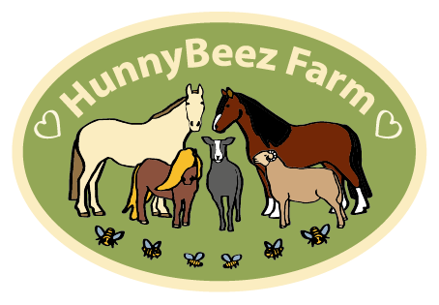

**HunnyBeez Care Farm & Stables**

**Environmental Policy**

Parklands strives to provide therapeutic rural experiences for anyone with additional needs. We use nature and the environment to offer topics such as

* Farming
* Horticulture
* Bee-keeping
* Rural Crafts
* Equestrian Skills

At parklands we strive to

* Minimise waste and maximise recycling
* Minimise our use of plastics and use recycled or compostable materials.
* Re-harvest our rain water for use in the gardens
* Re-wild our land with native species – ideal to support our declining bee populations
* Use local businesses both to offer support and to reduce air miles.
* Re-use our suitable animal waste for compost.

For the safety of our bees we keep our farm as organic as possible.

This policy is in constant review to ensure was have a positive impact on the environment.

Signed………………………………………………………………………. Date………………………………………………